**SMARTINTERNZ**

**TOXIC COMMENTS CLASSIFICATION APP USING IBM**

An Internship Project Report

Submitted By

(BATCH NO: CSE_AIML_D13)

V.S.N.S GAYATHRI (18481A05L6)

                              R.LAKSHMI NAVEEN KUMAR (18481A05I4)

V.RAHUL NADH (18481A05N1)

**INDEX**

**TITLE PAGE NO**

**CHAPTER 1: INTRODUCTION 2-4**

* 1. OVERVIEW 2-3
  2. PURPOSE 3-4

**CHAPTER 2: LITERATURE SURVEY 4-5**

* 1. EXISTING PROBLEM 4-5
  2. PROPOSED SOLUTION 5

**CHAPTER 3: THEORETICAL ANALYSIS 5-8**

3.1 BLOCK DIAGRAM 5-6

3.2 HARDWARE/SOFTWARE DESIGNING 6-8

**CHAPTER 4: EXPERIMENTAL INVESTIGATIONS 8-9**

**CHAPTER 5: FLOW CHART 9-10**

**CHAPTER 6: RESULTS 10-11**

**CHAPTER 7: ADVANTAGES AND DISADVANTAGES 11**

**CHAPTER 8: APPLICATIONS 11-12**

**CHAPTER 9: CONCLUSION 12**

**CHAPTER 10: FUTURE SCOPE 12-13**

**CHAPTER 11: BIBLIOGRAPHY 13-14**

**CHAPTER12: APPENDIX 14-17**

12.1 SOURCE CODE 14-15

12.2 UI OUTPUT SCREENSHOTS 15-17

**CHAPTER 1**

**INTRODUCTION**

**1.1Overview:**

A large proportion of online comments present on public domains are usually constructive,however a significant proportion are toxic in nature.Dataset is obtained online which are processed to remove noise from the dataset.The comments contain lot of errors which increases the number of features manifold,making the machine learning model to train the dataset by processing the dataset,in the form of transformation of raw comments before feeding it to the Classification models using a machine learning technique known as the term frequency-inverse document frequency(TF-IDF) technique.The logistic regression technique is used to train the processed dataset,which will differentiate toxic comments from non-toxic comments.The multi-headed model comprises toxicity(severe-toxic,obscene,threat,insult and identity-hate) or Non-Toxicity Evaluation,using confusion metrics for their prediction.

The project flow to be followed while developing the project is :

* Download the dataset.
* Preprocess the textual data.
* Classify the dataset into train and test sets.
* Add the neural network layers.
* Load the trained data and fit the model.
* Test the model.
* Save the model and its dependencies.
* Build a Web application using flask that integrates with the model built.

**1.2Purpose:**

By Toxic Comments Classification App using IBM we will be :

* Able to understand the problem to classify if it is a regression or a classification kind of problem.
* Able to know how to pre-process/clean the data using different data pre-processing techniques.
* Applying different algorithms according to the dataset
* Able to know how to find the accuracy of the model.
* Able to build web applications using the Flask framework.

**CHAPTER 2**

**LITERATURE SURVEY**

* 1. **Existing Problem:**

Over the years,the flow of data over the internet has grown dramatically, especially with the appearance of social networking sites.Social networks sometimes become a place for threats,insults,and other components of cyberbullying.A huge number of people are involved in online social networks.

Toxic comments are textual comments with threats,insults,obscene,racism, etc.In recent years there have been many cases in which authorities have arrested some users of social sites because of the negative(abusive) content of their personal pages.As a result,different platforms and communities find it very difficult to facilitate fair conversation and are often forced to either limit user comments or get dissolved by shutting down user comments completely.

* 1. **Proposed Solution:**

The protection of network users from anti-social behaviour is an important activity.One of the major tasks of such activity is automated detecting the toxic comments.This project focuses on building a multi-headed model to detect different types of toxicity like threats,obscenity,insults,and identity-based hate.Bag of words statistics and bag of symbols statistics are the typical source information for the toxic comments detection.Usually,the following statistics-based features are used:length of the comment,number of capital letters,number of exclamation marks,number of question marks,number of spelling errors,number of tokens with non-alphabet symbols, number of abusive, aggressive, and threatening words in the comment,etc.A neural network model is used to classify the comments.

**CHAPTER 3**

**THEORETICAL ANALYSIS**

**3.1 Block Diagram:**

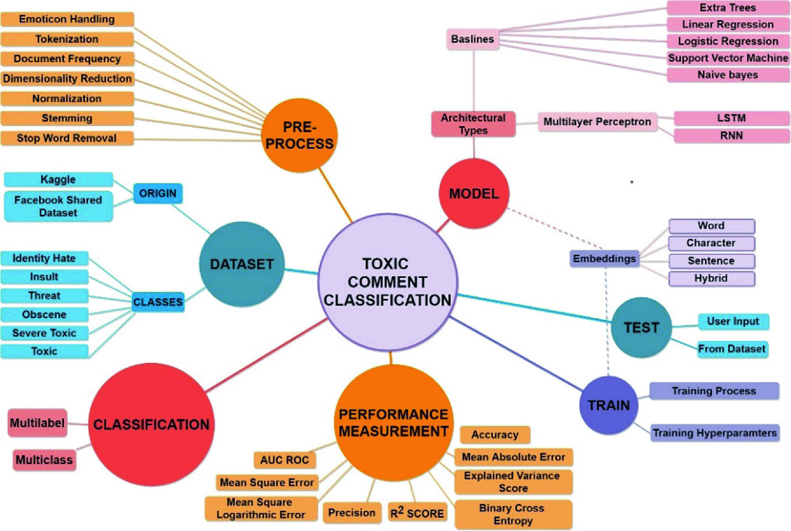

**3.2 Hardware/software designing:**

**Software specifications:**

|  |  |
| --- | --- |
| **REQUIREMENT** | **SPECIFICATION** |
| Anaconda Navigator(Anaconda3) | It is a free and open-source distribution of the Python and R programming languages for data science and machine learning related applications. It can be installed on Windows, Linux, and macOS.Conda is an open-source, cross-platform, package management system. Anaconda comes with great tools like JupyterLab, Jupyter Notebook, QtConsole, Spyder, Glueviz, Orange, Rstudio, Visual Studio Code.For this project, we used Jupyter notebook and Spyder. |
| IBM Cloud | IBM Cloud is a suite of cloud computing services from IBM that offers both platform as a service (PaaS) and infrastructure as a service (IaaS). With IBM Cloud IaaS, organizations can deploy and access virtualized IT resources such as compute power, storage and networking over the internet.We can create a python flask app in IBM cloud and we we can use Cloud Foundry CLI to deploy in IBM Cloud. |
| Web browser | It supports all web browsers like Microsoft Edge,Google Chrome,Mozilla Firefox etc. |

**Hardware Specifications:**

|  |  |
| --- | --- |
| **REQUIREMENT** | **SPECIFICATIONS** |
| Operating system | Microsoft Windows  UNIX  Linux® |
| Processing | Minimum: 4 CPU cores for one user. For each deployment, a sizing exercise is highly recommended. |
| RAM | Minimum 10 GB. |
| Operating system specifications | File descriptor limit set to 8192 on UNIX and Linux. |
| Disk space | A minimum of 4 GB of free space is required to install the software. |

**CHAPTER 4**

**EXPERIMENTAL INVESTIGATIONS**

**Analysis or the investigation made while working on the solution:**

While working on the solution we investigated on what is Toxic Comment Classification, Flask, IBM cloud, and how to add neural networking layers and working with the Logistic Regression model and finally deploying it. The key role on investigation is choosing the appropriate model.

**IBM Cloud Account**:

IBM Acquired soft layer, a public cloud platform, to serve as the foundation for its IaaS offering. In October 2016, IBM rolled the soft layer brand under its Blue mix brand of PaaS offerings, giving users to access both IaaS and PaaS resources from a single console. IBM cloud provides a full-stack, public cloud platform with various products in the catalog, including options for compute, storage, networking, end to end developer solutions for app development, testing and deployment, security databases, and cloud native services.

Creating the IBM cloud academic account by going to the IBM cloud login page and click create on IBM cloud account. Enter our IBM id and an ID is created based on the email that we enter. Completing the remaining fields with our information and click create account by this the account is created.

**CHAPTER 5**

**FLOW CHART**

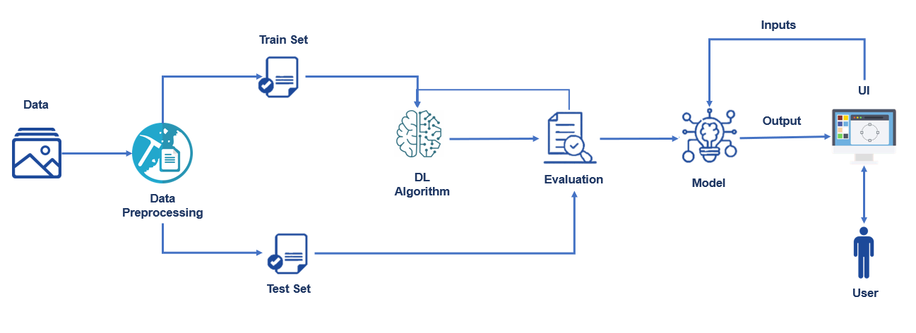

**CHAPTER 6**

**RESULTS**

* The user gives the input values from the UI interface

which is created by using the Flask Application

* The user inputs are given to the AI which consists of the

machine learning model.

* This model performs the data pre-processing and logistic regression classification using text--processing on the given input values and predicts the output.
* The output will be sent to the Flask application

using an HTTP request and displays it to the user.

**CHAPTER 7**

**ADVANTAGES AND DISADVANTAGES**

**Advantages:**

* Lower costs - reduces maintenance due to use of machine learning techniques, supervised learning classification algorithms and models.
* Faster results - shortens predicting time due to seamless integration and adaptive authoring.
* Improved decision making - it presents data in easily-understood formats.
* High performance data access across all sources.
* Ability to classify any type of sentence or comment even with the punctuation marks etc.

**Disadvantages:**

* Requires an internet connection.
* Invalid inputs may produce inaccurate results.

**CHAPTER 8**

**APLLICATIONS**

**The areas where the logistic regression can be applied:**

* It is used in Credit scoring.
* It is used in Medical field.
* It is used in Hotel booking.
* It is used in Text editing.
* It is used in Gaming.

**CHAPTER 9**

**CONCLUSION**

Logistic regression is one of the classic machine learning methods. It forms a basis of machine learning along with linear regression, k-mean clustering, principal component analysis, and some others. Neural networks were developed on top of logistic regression. You can successfully use logistic regression in your tasks even if you are not a machine learning specialist. But it is very unlikely that someone can become a good machine learning specialist without knowledge of logistic regression.

**CHAPTER 10**

**FUTURE SCOPE**

Logistic regression is simpler than modern deep learning algorithms, but simpler algorithms don't mean worse. There are many cases where logistic regression is more than enough. It also has advantages that are very significant in real cases.

First of all, it’s very simple to use. Logistic regression is realized in many statistical packages such as SAS, STATISTICA, R packages, and other tools. This makes it easy to use even if you do not have an advanced machine learning team for your task.

The second advantage is speed, and sometimes this is crucial.

Lastly, the most significant advantage of logistic regression over neural networks is transparency. Neural networks work as a black box - you never know why it makes one or another decision. There are a lot of highly regulated industries where this approach is not acceptable. Logistic regression, in contrast, may be called the “white box”.

**CHAPTER 11**

**BIBLIOGRAPHY**

References of previous works or websites visited/books referred for analysis about the project, previous solution findings etc.

* Qian, M.,Sherief, E.,Belding-Royer, E., Wang. W., (2018). Leveraging Intra-User and Inter-User Representation Learning for AutomatedHate Speech Detection, Proceedings of the 2018 Conference of the North American Chapter of the Association forComputational Linguistics: Human Language Technologies, vol. 2.
* Waseem, Z., Thorne, J., Bingel, J.,(2018). Bridgingthegaps:Multitask Learningfor Domain Transfer of Hate Speech Detection. Online Harassment, pp 29–55.

**CHAPTER12**

**APPENDIX**

**12.1 Source code:**

* Install Anaconda Navigator and all required Packages.

1)Run code in Jupyter notebook and Spyder.

2)Install Flask in Anaconda prompt.

3)Change the current directory to C:/Users/Nature/Downloads/Comment- Toxicity- Multi- Class- Classification- main/ flask.

4)Run commentApp.py in the command prompt.

* Create IBM account.

1)Request for feature code.

2)Go to catalog.

3)Add feature code in subscription section.

4) In search bar type "flask python app".

5)Click on create button.

6)Add details and app name to it.

* Deploy in IBM cloud.

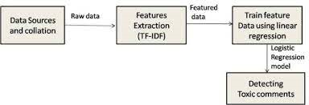

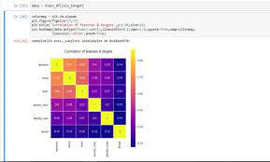

**Correlation matrix of Categories**

**12.2 UI Output Screenshots:**

